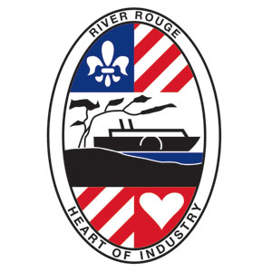
VACANT PROPERTY REGISTRATION FORM
Building Department City of River Rouge
10600 W. Jefferson Ave, River Rouge, MI 48518
(313) 842-4209 (313) 842-4208

PROPERTY INFORMATION
Address of Vacant Property:
Parcel’s Tax Identification Number (if known):
Property Type: Single Family Multiple Family Commercial Industrial
Utilities: Water On Off Gas On Off Electricity On Off Winterized On Off

PROPERTY OWNER
Name:
Contact Name (if business):
Address:
City: State: Zip:
Phone Number: E-Mail:

PROPERTY MANAGER / EMERGENCY CONTACT
Company Name:
Address:
City: State: Zip:
Contact Person:
E-Mail Address:
Business Phone: 24-Hour Phone:

REGISTRATION FEE: $100.00 PER UNIT PER YEAR.
Make checks payable to “City of River Rouge”
Fill out the information requested above, sign and deliver or mail this payment to:

City of River Rouge
Attention: Building Department
10600 W. Jefferson Ave.
River Rouge, MI 48218

Signature |  | Print Name |  | Date

